2025 REFEREE FORM
TO BE USED BY REFEREES FOR ELIGIBLE CANDIDATES
FOR THE 2026 SPECIALTY EXAMINATION
LARGE ANIMAL INTERNAL MEDICINE

Each referee must provide one PDF copy of the completed Referee Form/letter. To ensure confidentiality, the letters from each referee should be submitted ONLINE through the Diplomate dashboard via www.ACVIM.org (Please see detailed instructions for online submission of referee letters by ACVIM Diplomates on the last page of this document. Non-ACVIM Diplomates must email their Referee Form/letter directly to Adam@ACVIM.org). Referees must be an ACVIM Diplomate or ACVIM associate who works in the candidate’s training program or has supervised the candidate.

If, for any reason, three letters are not present by July 1, 2025, the candidate’s credentials will be rejected.

Letter of assessment for Dr. by Dr.

Candidate’s Residency Program: OR

Current Employment if no longer in a residency program:

1. Are you an active ACVIM Member or an active ACVIM associate who has worked in the candidate’s training program? An active member is one who is current on their membership dues and, for diplomates certified in 2016 and later, has fulfilled the requirements for Maintenance of Credentials (CM section 3.G; SM section 12).

Yes No

2. During what time period and in what capacity did you observe the clinical, professional and/or educational activities of the candidate? If not applicable, write "None".

3. To your knowledge, has the candidate progressed satisfactorily through the program and fulfilled the clinical training requirements necessary to sit for the Specialty Examination?

Yes No

If you answered "No" please explain below.

4. Are you aware of any characteristics of professional performance or of attitudes toward people or animal patients that would detract from the candidate's fitness to sit for the Specialty Examination in Large Animal Internal Medicine or become a member of the ACVIM community?

Yes No

If you answered "Yes" please explain below.

5. Do you recommend that the above candidate be permitted to take the Specialty Examination in Large Animal Internal Medicine?

Yes No

If you answered "No" please explain below.

Date:

Signed:

Address:
Department

Hospital/University

Address

City, State, Zip COUNTRY

- Visit the ACVIM.org website and login at the top right-hand corner of the screen.
Please contact Certification@ACVIM.org if you are having any login difficulties.

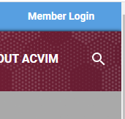
2. Click the “My Dashboard” link at the top middle of the page after logging in.

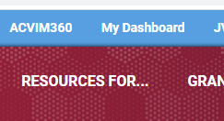
3. Under ‘Document Uploads’ click ‘Upload Document.’
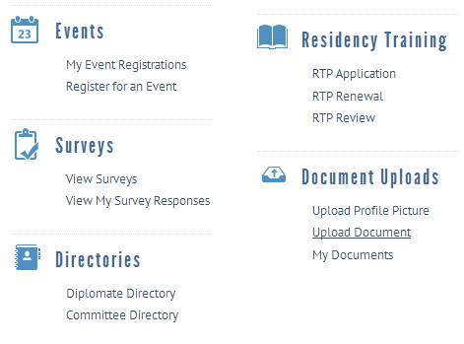
4. Follow the prompts, fill in details and upload documents as needed to referee form submission.
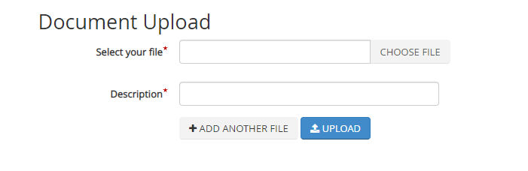
*In the document description field, please use the following format: Candidate Last Name, Candidate First Name

